
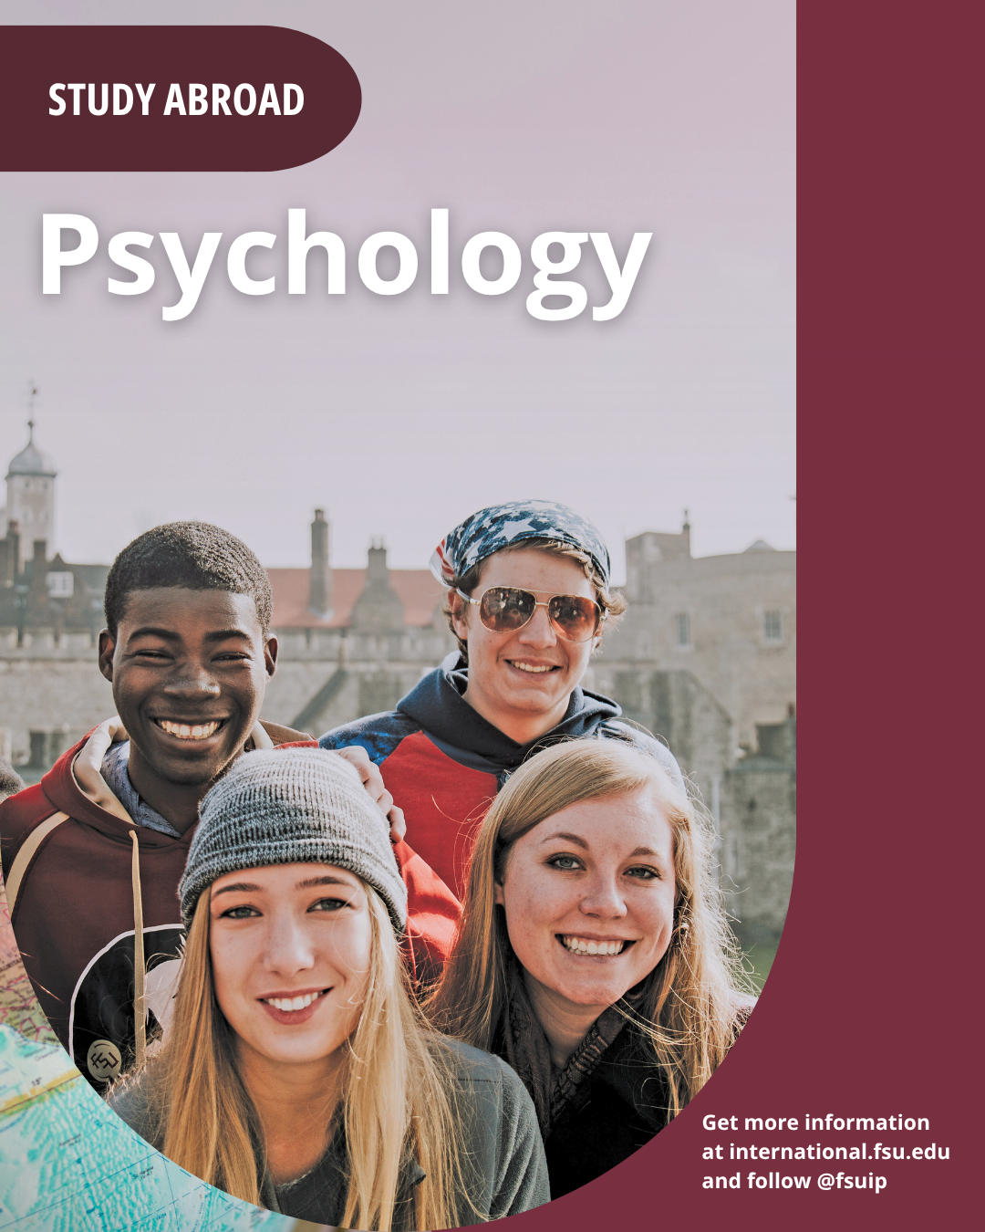
Psychology in London program (LN97-6-27) Summer 2027, June 17, 2027 through July 25, 2027)
You take two courses not offered in Tallahassee. Both count as 4000-level psychology electives that can be used toward the psychology major or minor. Both include small class size (30-40 students) and a variety of course-related excursions in London. The cost is $10,840. Bright Futures, Florida Prepaid, and 529 Plans Apply. Scholarships, grants, and loans are available. For additional information, scan the QR code on the previous page. Applications open October 14th at 9 am. The application fee is $100. Be sure to apply as soon as you know that you want to go, as the program can be filled. You can apply by following the link below: https://international.fsu.edu/program/london/focused-curriculum/ln97.
Both instructors are recent winners of university-wide awards!

Dr. Orenda Johnson is the recipient of FSU’s 2026-2027 Distinguished Teacher Award, the university’s highest teaching honor, for her long-term excellence and commitment to student success. https://news.fsu.edu/news/university-news/2026/04/20/its-a-huge-honor-fsu-psychology-professor-orenda-johnson-wins-distinguished-teacher-award/. She will be teaching PSY4930 Special Topics in Psychology: Everyday Neuroscience: Explore London, Explore Your Mind. This course focuses on the neuroscience behind evidence-based, accessible practices to support mental and physical health, such as sleep, stress management, nutrition and the gut-brain axis, music and art, exposure to nature, physical activity, and social connectedness. Instruction and exploration also include an evaluation of the strength of evidence for these practices, and opportunities and limitations inherent in their study and utility.

Dr. Pamela Keel was named the 2025-2026 FSU Robert O. Lawton Distinguished Professor, the highest honor that faculty members can bestow on one of their own. “Pamela Keel’s impressive and undeniable impact on mental health research sets her apart as a researcher and scholar, but it’s her equal dedication to teaching that exemplify what it means to be a professor,” said FSU President Richard McCullough. https://news.fsu.edu/news/university-news/2025/05/01/esteemed-fsu-psychologist-named-2025-2026-fsu-robert-o-lawton-distinguished-professor/. She will be teaching PSY4930 Special Topics in Psychology: Eating Disorders in London. This course presents an in-depth investigation of eating disorders, examining them in the cultural and historical context in which they were first identified. Although often linked to social media’s obsession with thinness, both anorexia and bulimia were first identified in patients in London, with the first cases of anorexia nervosa diagnosed in the late 1800’s by Sir William Gull. Further evidence of anorexia dates back to medieval saints and Welsh Fasting Girls. London will serve as a classroom with excursions contributing to a more nuanced understanding of the cultural contexts in which eating disorders first emerged – highlighting how cultural factors and timing differ between diagnoses. The course will present current understandings of causes, correlates, and outcomes of eating disorders, highlighting their complexity and ongoing controversies. London is the home of leading clinicians and researchers, and the course will end with an excursion to a leading research and treatment center in London.

An informational meeting will be held on Friday, September 25th at 3:30 in Room A211 of the Psychology Building. It is Family Weekend, so please invite members of your family if they are in town!
Other Important Dates and Fees:
Program Applications Open on 10/14/2026. Application fee $100
IP Scholarship Applications Open on 11/2/2026 and are due 12/30/2026.
Commitment Fee of $1,500 is due on 1/12/2027.
Final Payment Due on 2/9/2027

Join us on Facebook! FSU Psychology in London
Send questions to Dr. Wagner rkwagner@psy.fsu.edu or Abigail French arfrench@fsu.edu. You also can call (850) 644-1059, (850) 644-3272, or (800) 374-8581.

